**Distributed Systems**

Lab 1 - Socket Programming

S Abhishek

AM.EN.U4CSE19147

**Server.c**

#include <stdio.h>

#include <sys/types.h>

#include <sys/socket.h>

#include <netinet/in.h>

#include <netdb.h>

#include <unistd.h>

#include <stdlib.h>

#include <strings.h>

void error(char *msg)

{

perror(msg);

exit(1);

}

int main(int argc, char *argv[])

{

int sockfd, newsockfd, portno, clilen;

char buffer[256];

struct sockaddr_in serv_addr, cli_addr;

int n;

if (argc < 2)

{

fprintf(stderr,"ERROR, no port provided\n");

exit(1);

}

sockfd = socket(AF_INET, SOCK_STREAM, 0);

if (sockfd < 0)

{

error("ERROR opening socket");

}

bzero((char *) &serv_addr, sizeof(serv_addr));

portno = atoi(argv[1]);

serv_addr.sin_family = AF_INET;

serv_addr.sin_addr.s_addr = INADDR_ANY;

serv_addr.sin_port = htons(portno);

if (bind(sockfd, (struct sockaddr *) &serv_addr,sizeof(serv_addr)) < 0)

{

error("ERROR on binding");

}

listen(sockfd,5);

clilen = sizeof(cli_addr);

newsockfd = accept(sockfd,(struct sockaddr *) &cli_addr, &clilen);

if (newsockfd < 0)

{

error("ERROR on accept");

}

bzero(buffer,256);

n = read(newsockfd,buffer,255);

if (n < 0)

{

error("ERROR reading from socket");

}

printf("Here is the message: %s\n",buffer);

n = write(newsockfd,"I got your message",18);

if (n < 0)

{

error("ERROR writing to socket");

}

return 0;

}

**Client.c**

#include <stdio.h>

#include <sys/types.h>

#include <sys/socket.h>

#include <netinet/in.h>

#include <netdb.h>

#include <unistd.h>

#include <stdlib.h>

#include <strings.h>

#include <string.h>

void error(char *msg)

{

perror(msg);

exit(0);

}

int main(int argc, char *argv[])

{

int sockfd, portno, n;

struct sockaddr_in serv_addr;

struct hostent *server;

char buffer[256];

if (argc < 3)

{

fprintf(stderr,"usage %s hostname port\n", argv[0]);

exit(0);

}

portno = atoi(argv[2]);

sockfd = socket(AF_INET, SOCK_STREAM, 0);

if (sockfd<0)

{

error("Error opening socket");

}

server=gethostbyname(argv[1]);

if (server==NULL)

{

fprintf(stderr,"error no such host\n");

exit(0);

}

bzero((char *)&serv_addr,sizeof(serv_addr));

serv_addr.sin_family=AF_INET;

bcopy((char *)server->h_addr,(char *) & serv_addr.sin_addr.s_addr,server->h_length);

serv_addr.sin_port = htons(portno);

if (connect(sockfd,&serv_addr,sizeof(serv_addr)) < 0)

{

error("ERROR connecting");

}

printf("Please enter the message: ");

bzero(buffer,256);

fgets(buffer,255,stdin);

n = write(sockfd,buffer,strlen(buffer));

if (n < 0)

{

error("ERROR writing to socket");

}

bzero(buffer,256);

n = read(sockfd,buffer,255);

if (n < 0)

{

error("ERROR reading from socket");

}

printf("%s\n",buffer);

return 0;

}

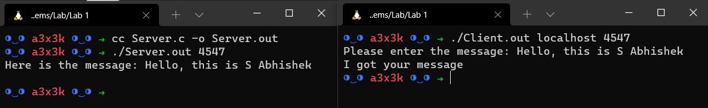

Thankyou!!